DUTCH-ARGENTINE PIG CHAIN
In the Netherlands, livestock farming is among the most advanced sectors. The Dutch integrated pig chain is innovative, efficient and sustainable. Close cooperation between government, agricultural entrepreneurs and knowledge institutions has resulted in state-of-the-art technology and breeding programs which are both sustainable and animal-friendly.

The GITAH Porcino Cluster wants to extend this invitation to work together with Argentina. Together we can provide the world with more efficient, environmentally-friendly, social and economic sustainable pig products. By working together, we can positively influence the lives of people and animals. Economic growth and jobs for people, improved health and well-being for animals.

The Argentinian pig sector has developed rapidly in recent years, and the combination of global trends and country’s natural conditions mean future prospects for the sector are bright. We would like to help Argentina take advantage of these trends: to become self-sufficient first, and cater to the international demand for pig meat afterwards. Through knowledge transfer and trainings we provide farmers with the tools to sustainably develop their business further and improve their own lives as well as that of their animals. People, animals, and planet all benefit.

By working together, we can accelerate the transition to more sustainable pig farming. So, let’s exchange information, knowledge, and technology and inspire each other and the rest of the world, how together we can farm the future!

The Netherlands Argentina
Surface: 41.543 km² 2.780.000 km²
Inhabitants: 17.4 million persons 45.4 million persons
Pigs: 12 million animals 5.2 million animals
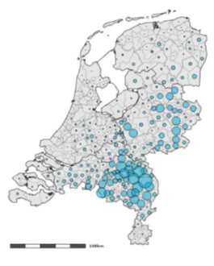
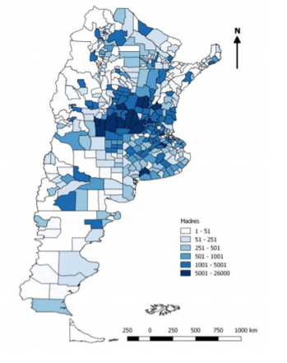
Number of sows
1-51
51-251
501-1001
1001-5001
5001-26.000

Location characteristics

Sandy soils Corn and soybean
production areas

